FOR IMMEDIATE RELEASE
Contact: Jill Dunkel
SHTX Executive Director
855-846-7468

Mike Major Captures Open Stock Horse World Championship Title

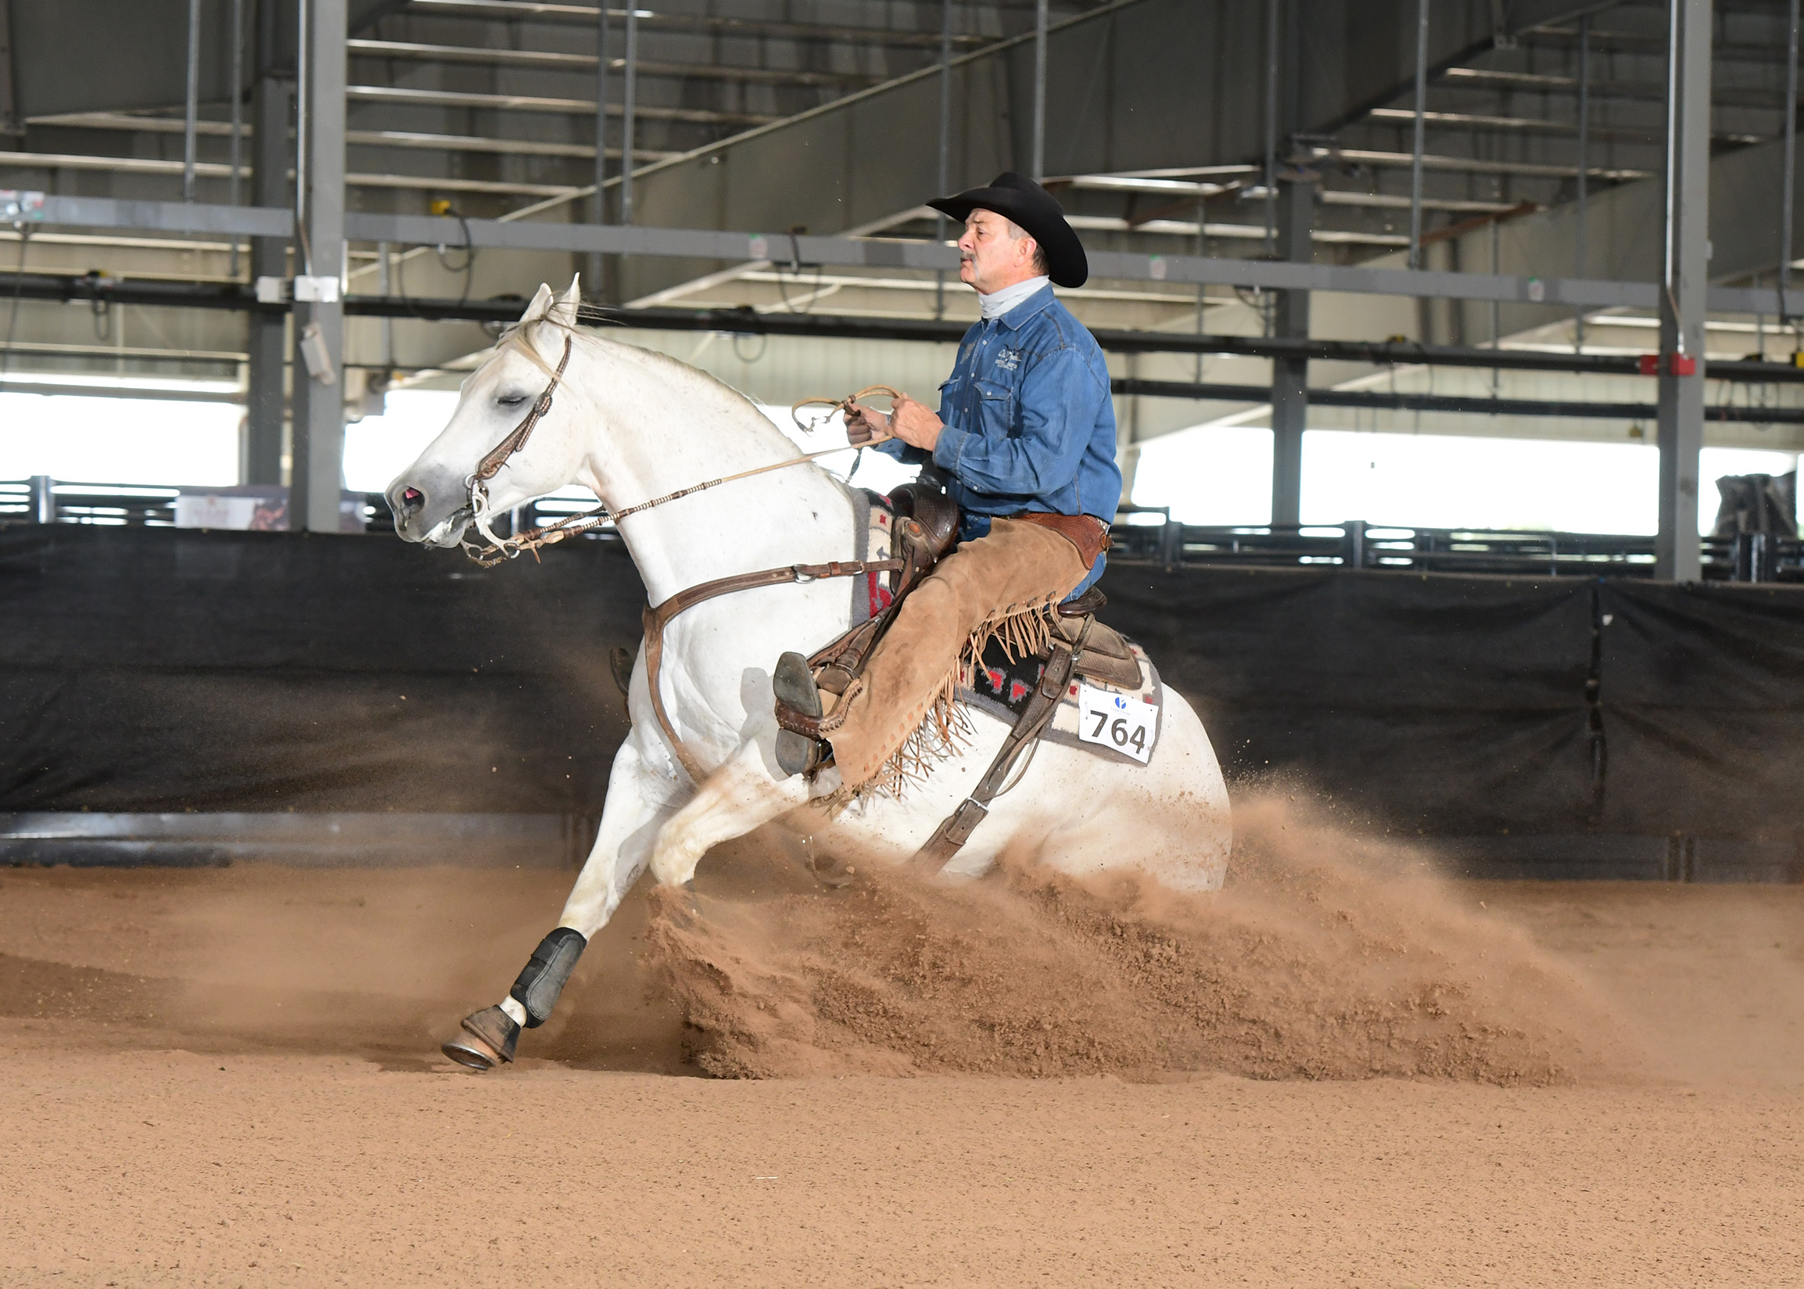
Cromeplated Sidekick left little doubt that he was the top Open horse at the 2020 the Western Horseman Stock Horse World Show held in Abilene, Texas. The 2009 grey gelding dominated the competition, winning cow work, stock horse trail and stock horse pleasure for owner Linda Bouziden-Lackey of Collinsville, Texas. Typically Linda is in the saddle at the stock horse events, but at the World Show, she trusted the reins to Mike Major of Bowie, Texas, while she watched from the stands. The duo won both go-rounds of competition, raking in $1,174 plus prizes and a world show buckle sponsored by Stormcloud clothing.

Despite the challenges of 2020, this was the ninth show for Stock Horse of Texas this year. All shows had strong numbers, and the world championship show was no different. Due to the show size, managers added a day of competition and as well as evening events including the Classic Equine Fence Work Showcase and Youth Freestyle Reining, sponsored by Elliott Ranches. Horses compete in reining, cow work, stock horse trail and stock horse pleasure in a two go-round format with prizes and payout presented for each round. In total, the show featured more than 1,800 entries and awarded $80,000-plus in cash and prizes.
Mike Major & Cromeplated Sidekick

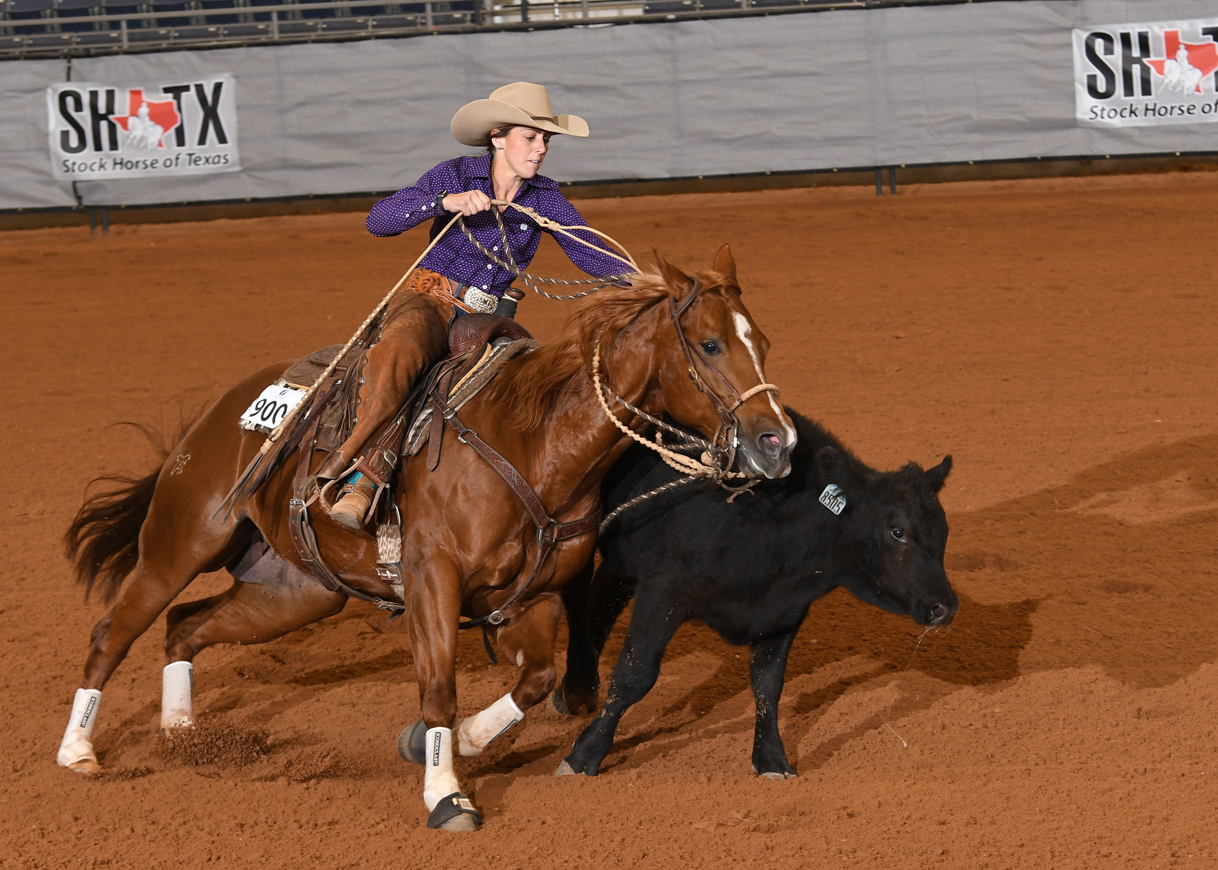
The four day show also featured a Stock Horse Derby with $6,000 Added, and an AQHA Ranching Heritage Challenge which qualified riders for the 2021 Ranching Heritage Finals. Topping the Open Derby was non pro rider Stefani Wagley of Abilene and her six-year-old mare Precious Metalz. Wagley was on a hot streak all week also winning the Stock Horse World Championship in the Non Pro division. The week of competition netted her more than $5,000.
Stefani Wagley & Precious Metalz
The Limited Derby championship went to Nonie Casselman-Reed riding Navajo Jo. The pair also won the four-year-old incentive to earn a total paycheck of $2,490.

New to the competition was the Texas Triple Threat Incentive which paid out $6,000 in cash to horses across all divisions that were Texas owned, Texas shown and Texas bred. Youth rider Skylar Duleba captured the top payout in the incentive to earn $1,680 riding Trinitys Merada.

“It’s such a fun week watching riders showcase the versatility of their horses,” said William Lewis, Stock Horse of Texas president. “These horses can go down the fence at full throttle, and then a little later navigate an intricate ranch trail course. These events truly display the awesome versatility of our horses.”

Other world champions include:
- Level 1 Open: Leanne Jetton aboard her horse, Bourbon N Branch
- Junior Horse: Susan Crews Morris on Rusty Dun It Smart
- Limited Non Pro: Larry Walker on Boots Be Tuff
- Intermediate Non Pro: Michelle Eiland with Hickorys Kitty Cat
- Novice: Sartia Short aboard Two Tone Shine
- Youth: Will Lewis and Spookin Jay
- Novice Youth: Audrey Hart and My Socks Do

Complete results from each go-round and a list of all the sponsors who made the show possible are available at www.stockhorsetexas.org

-30-

Photo downloads; please credit Willie Gomez Photos
Mike Major and Cromeplated Sidekick
Stefani Wagley and Precious Metalz

Photos of every world champion are available on request.

